Why China’s Affordable AI Is a Worry for Silicon Valley
Chinese AI models are cheaper and more adaptable than the preeminent US platforms, and studies suggest they’re now almost as proficient. How did that happen?

By Saritha Rai
April 27, 2026

Chinese artificial intelligence companies can't match the financial firepower of their American rivals, and the US government has deprived them of the most cutting-edge chips to train their AI models. Yet China is encroaching on US leadership in the field.
Chinese developers such as DeepSeek and Alibaba Group Holding Ltd. have focused on devising systems that perform almost on a par with the top-performing AI models without needing the most powerful hardware. And China is making a bet on “open-weight” AI software — where the internal parameters are made available for developers to share, study and tweak — as a way to foster rapid adoption of AI across the national economy. All this challenges the dominant US business model that’s predicated on investing billions and getting users paying top-dollar for the most powerful, proprietary AI technology.
Here’s what to know about Chinese AI and how much of a threat it poses to OpenAI Inc., Anthropic and other US giants.

Efficiency
Export controls imposed by Washington restrict China’s access to US-designed chips that are around 20% faster and consume as much as 30% less power than their Chinese competitors as they squeeze more transistors onto each sheet of silicon. China’s tech community has sought to overcome this handicap by developing AI software that is more “compressed.” This means fewer steps of calculation are required to achieve outputs comparable to those of the best-performing US AI models.
One way this is achieved is by employing a technique known as mixture of experts. When a user prompts a Chinese chatbot such as DeepSeek or Alibaba’s Qwen, the model doesn’t need to mobilize its entire “neural network” to generate a response (the process known as inference). Instead, it activates specialized sub-networks known as experts that engage only a fraction of the software’s available computational capacity.
The models of US labs such as OpenAI and Anthropic often have the edge when it comes to the sheer volume of information they can handle in a single interaction and the sophistication of their responses. But to achieve this, they activate far more of a model’s available “neurons” and thereby consume a lot more computing power. With DeepSeek’s latest model, V4-Pro, less than 3% of its parameters are actually doing work at any given moment, according to performance data released by the company.

Closing In
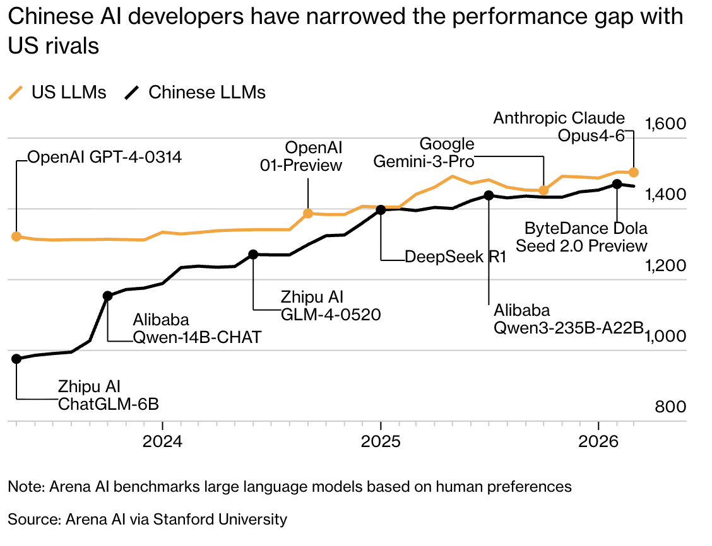
Global technology stocks tumbled in late January 2025 after DeepSeek demonstrated a new model, R1, that offered comparable performance to US AI chatbots at seemingly a fraction of their development cost. Today, while OpenAI, Anthropic and Google still offer the world’s best-performing AI tools, DeepSeek and smaller Chinese rival Moonshot now feature among the top 12, according to LiveBench’s large language model rankings. And they are far cheaper: OpenAI’s GPT-5.2 cost $14 per million output tokens (the units of data processed by AI models in response to a user prompt) as of February — around 33 times more than DeepSeek’s V3.2-Exp, at 42 US cents per million tokens.
Anthropic has accused DeepSeek, Moonshot and another Chinese AI lab, MiniMax, of “industrial-scale distillation attacks” — illegally extracting capabilities from its proprietary Claude model using 24,000 fraudulent accounts to gain an edge. Since then, Anthropic, OpenAI and Google have been collaborating to try to stamp out such practices. DeepSeek, Moonshot and MiniMax did not respond to emails seeking comment.

Open architecture
The new crop of AI tools work by ingesting all kinds of information recorded by humans to spot patterns in the data and record the most common relationships between syllables, words, sounds or pixels. From this, they build a vast neural network that can break down the components of a written prompt and send back the most probable useful response based on the training data.
The leading US platforms don’t publish the parameters of AI models such as ChatGPT, Claude or Gemini. So third-party AI developers are either unable to replicate them or they need to pay for that privilege. While Chinese AI companies can be just as secretive about what data they’ve used to train their systems, many have made the parameters assigned as numerical values and tweaked during the training of their AI models — known as weights — available for download. This allows universities, startups and smaller tech firms to build upon and adjust the models so they can better perform specific tasks at no extra cost.
This approach effectively crowdsources national AI research and development, lowering the cost of maintaining and updating the models. And the added model flexibility eases the adoption of AI across a swath of industries.
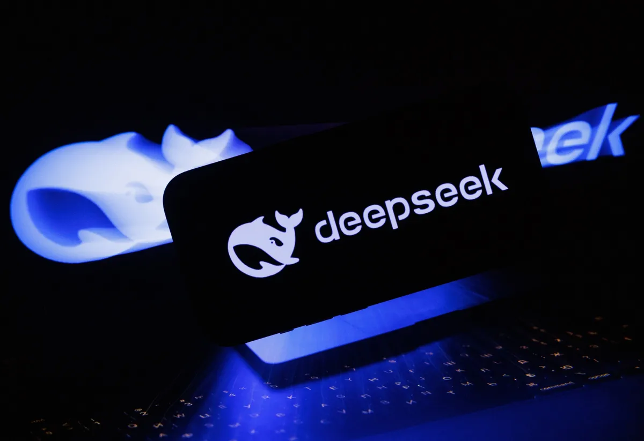
The DeepSeek artificial intelligence logo.Photographer: Andrey Rudakov/Bloomberg
R1 saw rapid uptake after DeepSeek released the model’s weights. Developers have produced versions of R1 for finance, medicine and Chinese language tasks. Alibaba’s Qwen family of AI models surpassed 1 billion downloads by January, making it the most widely downloaded open-source AI model family ahead of the Llama platform of Mark Zuckerberg’s Meta Platforms Inc. Alibaba said Qwen has spawned more than 200,000 derivative AI models worldwide.
Regional governments in China have been funding open-weight models and encouraging the emergence of AI communities that host thousands of models and datasets as communal assets that can be shared for the benefit of local companies. China’s government sees this approach, designed to broaden the technology's adoption across the economy even if it cuts into the profits of individual tech firms, as a tool of soft power. It’s an active sponsor of initiatives such as the July 2025 Global AI Governance Action Plan that seek to make AI models more accessible to software developers in lower-income nations.

Energy
As training and operating AI services consumes massive amounts of electricity, their rapid adoption is straining energy networks around the world. In some countries, it’s proving a struggle to install the new power stations, solar and wind farms, transmission lines, substations and transformers required to handle the surge in demand.
This is proving to be less of a problem in China, which has been adding generation capacity faster than other countries. In some Chinese regions, such as Inner Mongolia, abundant and cheap electricity from renewable sources has led to the construction of hundreds of data centers dedicated to training AI models.
China’s government is capping electricity bills for its AI companies to give them a competitive advantage over foreign rivals. The state is subsidizing half of the electricity costs of some of the country’s biggest data centers — as long as they use solely Chinese chips.
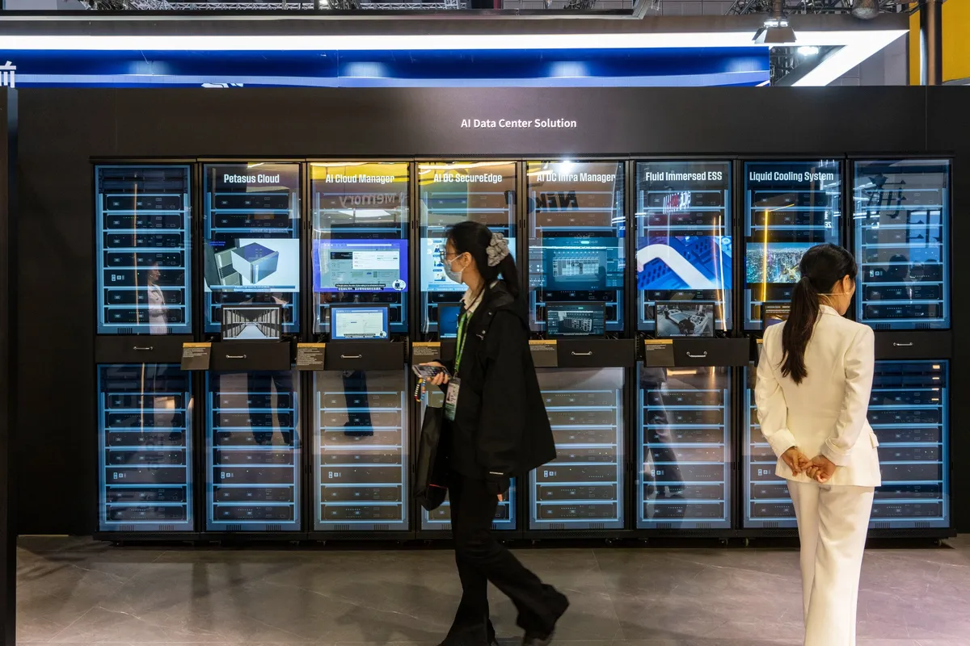
A mock-up of an AI data center on display at the SK Hynix booth at the China International Import Expo (CIIE) in Shanghai, China, on Nov. 6, 2025.Photographer: Qilai Shen/Bloomberg

Industry
In much of the world, the push for AI adoption is most intense in business services: automating customer relations, accelerating business workflows and accelerating productivity in sectors such as finance, law and healthcare. China’s state-directed approach places the emphasis on raising national productivity by embedding AI in commerce, manufacturing and logistics.
That’s perhaps not a surprise: The US economy is largely services-based. China is the world’s dominant producer of manufactured goods, including electric vehicles and other low-carbon technologies, an e-commerce powerhouse and an emerging leader in robotics. China installed more than half of the world’s new industrial robots in recent years, according to the International Federation of Robotics, as Chinese manufacturers automated inspection, assembly and logistics. The government has made clear its goal is not to create the biggest, wealthiest AI companies, but to use AI to gain a technological edge to accelerate economic development.
US companies and academic institutions lead in the basic, long-term scientific work aimed at advancing the foundational technology behind AI. China’s AI community is more focused on accumulating massive data sets from deployed AI that can be fed back to improve models. Carmaker BYD has embedded AI in its EV assembly lines to shorten cycle times and reduce material waste. It’s documented a 40% decrease in battery faults and a 20% improvement in battery longevity that it attributed to AI-enabled quality assurance.
Apple Inc.’s Chinese iPhone assembly partner, Foxconn, has deployed AI-driven computer vision to detect defects and optimize energy use on production lines. It said this resulted in a double-digit percentage reduction in energy consumption at some sites, while automated quality inspections carried out with AI cut defect rates. E-commerce giant Alibaba’s AI systems now handle most routine customer service.
The government is encouraging, and even providing funding, for the deployment of AI-enabled robots in manufacturing, logistics and service tasks as a way to overcome growing manpower shortages due to a shrinking working-age population. Officials in Beijing are proceeding with caution, given the risk that a sudden, wholesale shift to automation might lead to mass layoffs and cause a wave of social unrest.

China's AI Research Blitz
Number of patents issued in 2023
Bank
China | 920,797
US | 315,245
Japan | 209,368
South Korea | 134,734
Europe | 104,609
Note: Europe figure is for European Patent Organisation countries
Source: World Intellectual Property Organization

National Strategy
Even if China’s tech entrepreneurs wanted to join the computing-power arms race being pursued by the American AI giants in search of giant profits, it’s not certain that they could. Chinese President Xi Jinping already made clear his disapproval of ostentatious wealth when he cracked down on the country’s free-wheeling billionaires from 2020 to 2023. He wants the nation’s capitalists to serve the Chinese Communist Party’s overriding objective — steady, job-creating economic growth.
In exchange, Xi’s government has been creating a national ecosystem to supply the country’s AI startups with scientific talent, cheap capital and commercial opportunities. A 2017 New Generation AI Development Plan aligned incentives across scientific institutions and the private sector. Universities would drive research and companies would commercialize their breakthroughs.
The latest state AI initiative launched in 2025, AI Plus, aims to embed the technology across the economy and society. Primary schoolchildren are learning to code and put together AI models. Local governments have built subsidized AI parks, and firms receive capital, easy access to a wealth of data for model training and guaranteed procurement opportunities. Several Chinese AI startups were founded by professors or alumni of elite universities following scientific breakthroughs and then quickly brought into the government’s orbit. AI developer Knowledge Atlas Technology JSC Ltd., or Zhipu AI, was founded by Tsinghua professors Tang Jie and Li Juanzi in 2019 and was encouraged to align with national goals. It secured government customers and backing from state funds such as Beijing Zhongguancun Science City Innovation Development and the Chengdu regional government, and benefited from state-supported computing resources and other policies favoring domestic AI champions.
All that state backing has compelled Chinese AI companies to align with national imperatives, so wide-scale deployment of the technology is set to take precedence over profits, according to a Bloomberg Intelligence deep dive report published in December.

Private Capital Spending on AI
In China, it's mostly government money driving the AI boom

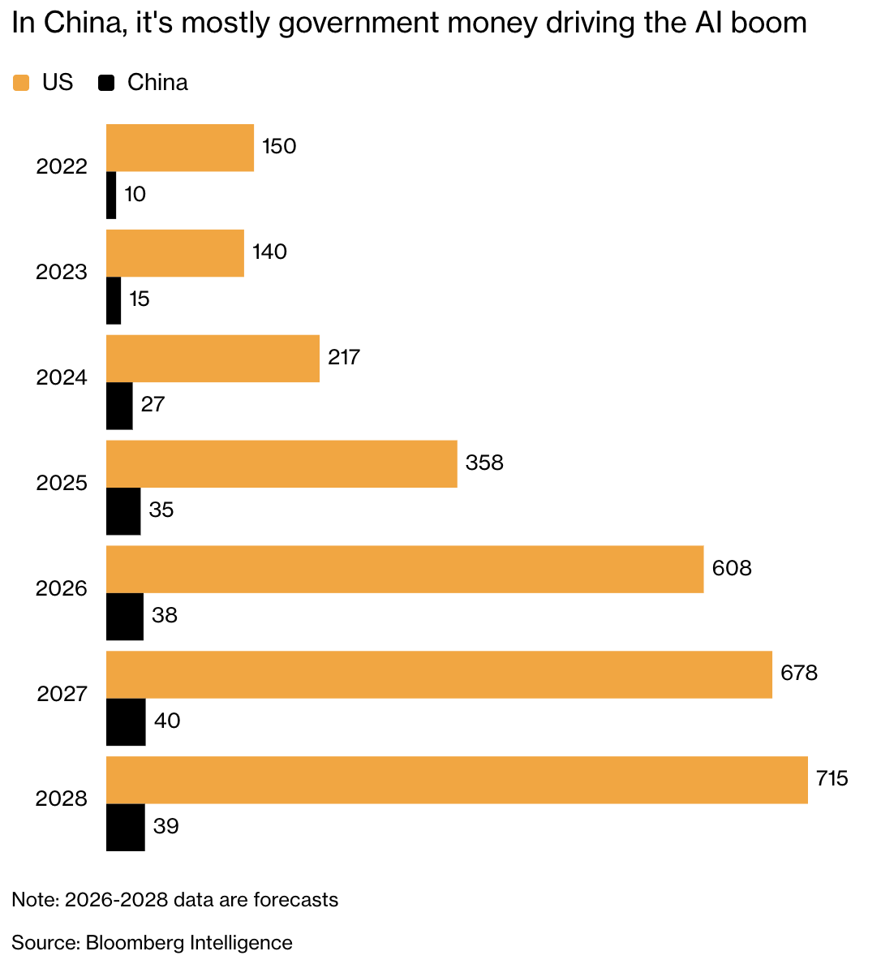Expanding abroad
The government in Beijing views Chinese open-weight models that can be embedded across industries as a national asset, akin to roads, power grids or telecommunication networks. This asset can be exported to other countries to foster dependence on Chinese technology.
Chinese and US AI platforms are competing in regions of Southeast Asia, the Middle East and Africa where the possibility of Chinese entities accessing government, corporate or personal data stirs fewer concerns than in Western countries.

Chinese tech giants Alibaba, Huawei Technologies Co. and Tencent Holdings Ltd. are seeking customers for their own cloud platforms in some of these fast-growing markets. Their plan is to undercut US rivals there by offering everything a customer needs to start using Chinese AI: the platform itself, such as Qwen or DeepSeek, low-cost, China-based cloud computing, an internet connection and the necessary hardware. They’ve adapted Chinese AI models to handle local languages and adhere to national regulations. And the Chinese government has sought to smooth their path by extending financing to many of those countries under its Belt and Road Initiative and other programs.
The approach appears to be working: Chinese generative AI models accounted for about 15% of global market share in November 2025, up from around 1% a year earlier, according to AI model marketplace OpenRouter.

Threat to American AI?
For now, the big Chinese players’ access to the US and European markets is fairly limited. Rules and regulations to do with data privacy and national security mean customers there — especially government entities and large corporations — are discouraged from using Chinese cloud computing services.
This hasn’t stopped big US cloud providers such as Microsoft Corp. and Amazon.com Inc. from offering Chinese AI models to their customers and handling the inference process in data centers outside China. The Chinese platforms are being offered as a more flexible and adaptable alternative to US models because of their open-weight approach. And because they tend to use less processing power in responding to user prompts, they can be a lot cheaper.

Both Chinese and US AI companies are spending heavily on the computing power needed to run their platforms. They buy that data-crunching capacity as a service from cloud operators such as Alibaba, Google, AWS or Microsoft. The huge investments being made in AI infrastructure are predicated on the expectation that these platforms will gradually become so indispensable to working life that the companies will be able to significantly increase the fees they charge users. For now, no one can say with any certainty when, or even if, those revenues will begin to cover all the spending.
That’s as much the case for Chinese AI companies such as Minimax — which is burning through large amounts of cash to pay Alibaba for computing capacity — as it is for OpenAI, Anthropic and other big-spending American players. Alibaba this year released several closed, proprietary AI platforms alongside its open-weight models, in a possible sign that Chinese players are also feeling the pressure to boost returns on their AI investments.
The concern for investors in American AI is that the lower cost base and improving performance of Chinese models will make it harder for the US giants to claim their services justify premium prices, and that significant numbers of users in Western markets will put aside any misgivings over data security and opt for the Chinese alternatives.
“US-allied countries are not going to be using DeepSeek in any official way,” said Robert Lea, a senior analyst at Bloomberg Intelligence. ”But in these cost-conscious times, if DeepSeek offers 90% of the functionality of ChatGPT, then consumers might take a different view to governments.”

